//////////////////////////////////////////////////////////////////////////////////////////////////////////////////////////

**Java Arrays**

//////////////////////////////////////////////////////////////////////////////////////////////////////////////////////////

Q364 Exercise

===========

import java.util.*;

class Example{

public static void main(String []args) {

Scanner input=new Scanner(System.in);

int a,b,c,d,e,f,g,h,i,j;

System.out.print("Input number 1 : ");

a=input.nextInt();

System.out.print("Input number 2 : ");

b=input.nextInt();

System.out.print("Input number 3 : ");

c=input.nextInt();

System.out.print("Input number 4 : ");

d=input.nextInt();

System.out.print("Input number 5 : ");

e=input.nextInt();

System.out.print("Input number 6 : ");

f=input.nextInt();

System.out.print("Input number 7 : ");

g=input.nextInt();

System.out.print("Input number 8 : ");

h=input.nextInt();

System.out.print("Input number 9 : ");

i=input.nextInt();

System.out.print("Input number 10: ");

j=input.nextInt();

//--------------------------------

int total=0;

total+=a;

total+=b;

total+=c;

total+=d;

total+=e;

total+=f;

total+=g;

total+=h;

total+=i;

total+=j;

System.out.println("Total : "+total);

    }

}

//////////////////////////////////////////////////////////////////////////////////////////////////////////////////////////

Q365 Exercise (iterate Q364)

=======================

import java.util.*;

class Example{

public static void main(String []args) {

Scanner input=new Scanner(System.in);

int a,b,c,d,e,f,g,h,i,j;

for(int k=0; k<10; k++){

System.out.print("Input number "+(k+1)+" : ");

a=input.nextInt();

}

/*

System.out.print("Input number 1 : ");

a=input.nextInt();

System.out.print("Input number 4 : ");

d=input.nextInt();

System.out.print("Input number 5 : ");

e=input.nextInt();

System.out.print("Input number 6 : ");

f=input.nextInt();

System.out.print("Input number 7 : ");

g=input.nextInt();

System.out.print("Input number 8 : ");

h=input.nextInt();

System.out.print("Input number 9 : ");

i=input.nextInt();

System.out.print("Input number 10: ");

j=input.nextInt();

*/

//--------------------------------

int total=0;

total+=a;

total+=b;

total+=c;

total+=d;

total+=e;

total+=f;

total+=g;

total+=h;

total+=i;

total+=j;

System.out.println("Total : "+total);

    }

}

//////////////////////////////////////////////////////////////////////////////////////////////////////////////////////////

**Using an array**

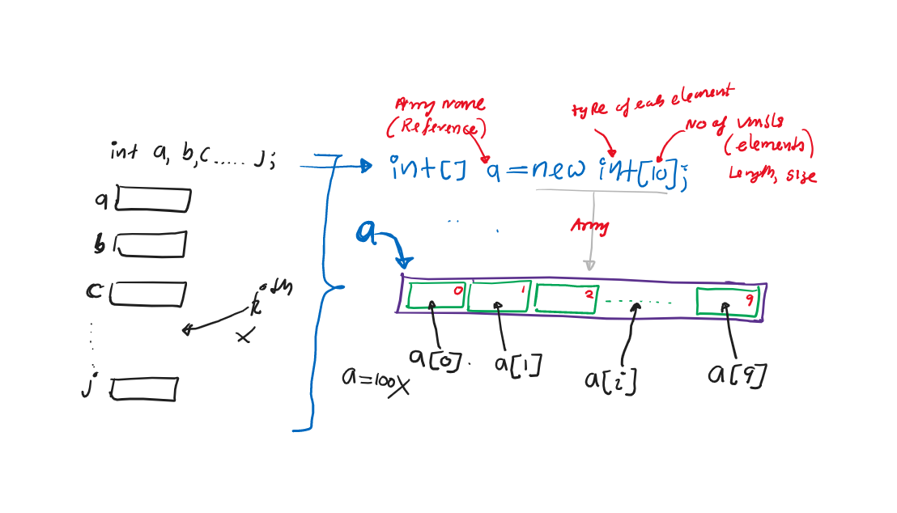

//////////////////////////////////////////////////////////////////////////////////////////////////////////////////////////

Q366 From Q364 Using a integer array

===============================

import java.util.*;

class Example{

public static void main(String []args) {

Scanner input=new Scanner(System.in);

int[] a=new int[10]; //int a,b,c,d,e,f,g,h,i,j;

System.out.print("Input number 1 : ");

a[0]=input.nextInt();

System.out.print("Input number 2 : "); //(i+1)

a[1]=input.nextInt();

System.out.print("Input number 3 : ");

a[2]=input.nextInt();

System.out.print("Input number 4 : ");

a[3]=input.nextInt();

System.out.print("Input number 5 : ");

a[4]=input.nextInt();

System.out.print("Input number 6 : ");

a[5]=input.nextInt();

System.out.print("Input number 7 : ");

a[6]=input.nextInt();

System.out.print("Input number 8 : ");

a[7]=input.nextInt();

System.out.print("Input number 9 : ");

a[8]=input.nextInt();

System.out.print("Input number 10: ");

a[9]=input.nextInt();

//--------------------------------

int total=0;

total+=a[0];

total+=a[1];

total+=a[2];

total+=a[3];

total+=a[4];

total+=a[5];

total+=a[6];

total+=a[7];

total+=a[8];

total+=a[9];

System.out.println("Total : "+total);

    }

}

//////////////////////////////////////////////////////////////////////////////////////////////////////////////////////////

Q367 From Q366 using iterations

===========================

import java.util.*;

class Example{

public static void main(String []args) {

Scanner input=new Scanner(System.in);

int[] a=new int[10];

for(int i=0; i<10; i++){

System.out.print("Input number "+(i+1)+" : ");

a[i]=input.nextInt();

}

/*

System.out.print("Input number 2 : ");

a[1]=input.nextInt();

System.out.print("Input number 3 : ");

a[2]=input.nextInt();

System.out.print("Input number 4 : ");

a[3]=input.nextInt();

System.out.print("Input number 5 : ");

a[4]=input.nextInt();

System.out.print("Input number 6 : ");

a[5]=input.nextInt();

System.out.print("Input number 7 : ");

a[6]=input.nextInt();

System.out.print("Input number 8 : ");

a[7]=input.nextInt();

System.out.print("Input number 9 : ");

a[8]=input.nextInt();

System.out.print("Input number 10: ");

a[9]=input.nextInt();

*/

//--------------------------------

int total=0;

for(int i=0; i<10; i++){

total+=a[i];

}

/*

total+=a[1];

total+=a[2];

total+=a[3];

total+=a[4];

total+=a[5];

total+=a[6];

total+=a[7];

total+=a[8];

total+=a[9];

*/

System.out.println("Total : "+total);

    }

}

//////////////////////////////////////////////////////////////////////////////////////////////////////////////////////////

Q368 Exercise

===========

import java.util.*;

class Example{

public static void main(String []args) {

Scanner input=new Scanner(System.in);

int[] a=new int[10];

for(int i=0; i<10; i++){

System.out.print("Input number "+(i+1)+" : ");

a[i]=input.nextInt();

}

//--------------------------------

int total=0;

for(int i=0; i<10; i++){

total+=a[i];

}

//insert code here to prints data

//[78, 56, 34, 12, 89, 12,.....]

System.out.println("Total : "+total);

    }

}

//////////////////////////////////////////////////////////////////////////////////////////////////////////////////////////

Q369 From Q368

==============

import java.util.*;

class Example{

public static void main(String []args) {

Scanner input=new Scanner(System.in);

int[] a=new int[10];

for(int i=0; i<10; i++){

System.out.print("Input number "+(i+1)+" : ");

a[i]=input.nextInt();

}

//--------------------------------

int total=0;

for(int i=0; i<10; i++){

total+=a[i];

}

//insert code here to prints data using a for-loop

//eg->[78, 56, 34, 12, 89, 12,.....]

System.out.print("[");

for(int i=0; i<10; i++){

System.out.print(a[i]+", ");

}

System.out.println("\b\b]");

System.out.println("Total : "+total);

    }

}

//////////////////////////////////////////////////////////////////////////////////////////////////////////////////////////

Q370 Exercise

===========

 import java.util.*;

class Example{

public static void main(String []args) {

Scanner input=new Scanner(System.in);

int[] a=new int[10];

//Read,input, store integers into array “**a”**  Using Random numbers  [0 to 100]

//--------------------------------

int total=0;

for(int i=0; i<10; i++){

total+=a[i];

}

//insert code here to prints data using a for-loop

//eg->[78, 56, 34, 12, 89, 12,.....]

System.out.print("[");

for(int i=0; i<10; i++){

System.out.print(a[i]+", ");

}

System.out.println("\b\b]");

System.out.println("Total : "+total);

    }

}

//////////////////////////////////////////////////////////////////////////////////////////////////////////////////////////

Q371 From Q370

==============

import java.util.*;

class Example{

public static void main(String []args) {

Scanner input=new Scanner(System.in);

int[] a=new int[10];

//Read,input, store integers [0 to 100] Using Random numbers

Random r=new Random();

for (int i = 0; i < 10; i++){

a[i]=r.nextInt(101); //0 to 100

}

//--------------------------------

int total=0;

for(int i=0; i<10; i++){

total+=a[i];

}

//insert code here to prints data using a for-loop

//eg->[78, 56, 34, 12, 89, 12,.....]

System.out.print("[");

for(int i=0; i<10; i++){

System.out.print(a[i]+", ");

}

System.out.println("\b\b]");

System.out.println("Total : "+total);

    }

}

//////////////////////////////////////////////////////////////////////////////////////////////////////////////////////////

Q372 Exercise

===========

import java.util.*;

class Example{

public static void main(String []args) {

Scanner input=new Scanner(System.in);

int[] a=new int[10];

//Read,input, store integers [0 to 100] Using Random numbers

Random r=new Random();

for (int i = 0; i < 10; i++){

a[i]=r.nextInt(101); //0 to 100

}

//Find total

int total=0;

for(int i=0; i<10; i++){

total+=a[i];

}

//find maximum

int max;

//find minimum

int min;

System.out.print("[");

for(int i=0; i<10; i++){

System.out.print(a[i]+", ");

}

System.out.println("\b\b]");

System.out.println("Total   : "+total);

System.out.println("Maximum : "+max);

System.out.println("Minimum : "+min);

    }

}

//////////////////////////////////////////////////////////////////////////////////////////////////////////////////////////

Q373 From Q372

==============

import java.util.*;

class Example{

public static void main(String []args) {

Scanner input=new Scanner(System.in);

int[] a=new int[10];

//Read,input, store integers [0 to 100] Using Random numbers

Random r=new Random();

for (int i = 0; i < 10; i++){

a[i]=r.nextInt(101); //0 to 100

}

//Find total

int total=0;

for(int i=0; i<10; i++){

total+=a[i];

}

//find maximum

int max=a[0];

for(int i=1; i<10; i++){

if(a[i]>max){

max=a[i];

}

}

//find minimum

int min=a[0];

for(int i=1; i<10; i++){

if(a[i]<min){

min=a[i];

}

}

System.out.print("[");

for(int i=0; i<10; i++){

System.out.print(a[i]+", ");

}

System.out.println("\b\b]");

System.out.println("Total   : "+total);

System.out.println("Maximum : "+max);

System.out.println("Minimum : "+min);

    }

}

//////////////////////////////////////////////////////////////////////////////////////////////////////////////////////////

Q374 Exercise

===========

import java.util.*;

class Example{

public static void main(String []args) {

Scanner input=new Scanner(System.in);

System.out.print("Input no of students : ");

final int N=input.nextInt();

//1. Create an array to store student's marks, named "marks", size “N”

//2. Read and store marks [Read random number 0 to 100]

//3. Find Total

//4. Find max

//5. Find min

//6. Print marks [45, 23,.....]

System.out.println("Total   : "+total);

System.out.println("Maximum : "+max);

System.out.println("Minimum : "+min);

    }

}

//////////////////////////////////////////////////////////////////////////////////////////////////////////////////////////

Q375 From Q374

==============

import java.util.*;

class Example{

public static void main(String []args) {

Scanner input=new Scanner(System.in);

System.out.print("Input no of students : ");

final int N=input.nextInt();

//1. Create an array to store student's marks, named "marks"

int[] marks=new int[N];

//2. Read and store marks [Read random number 0 to 100]

Random r=new Random();

for(int i=0; i<N; i++){

marks[i]=r.nextInt(101); //0 to 100

}

//3. Find Total

int total=0;

for (int i = 0; i < N; i++){

total+=marks[i];

}

//4. Find max

int max=marks[0];

for (int i = 1; i < N; i++){

if(marks[i]>max){

max=marks[i];

}

}

//5. Find min

int min=marks[0];

for (int i = 1; i < N; i++){

if(marks[i]<min){

min=marks[i];

}

}

//6. Print marks [45, 23,.....]

System.out.print("[");

for (int i = 0; i < N; i++){

System.out.print(marks[i]+", ");

}

System.out.println("\b\b]");

System.out.println("Total   : "+total);

System.out.println("Maximum : "+max);

System.out.println("Minimum : "+min);

    }

}

//////////////////////////////////////////////////////////////////////////////////////////////////////////////////////////

Q376 Case I

==========

import java.util.*;

class Example{

public static void main(String []args){

int x;

x=100;

System.out.println(x);

int[] xr;

xr=new int[5];

System.out.println(xr);

xr[0]=100;

System.out.println(xr[0]);

    }

}

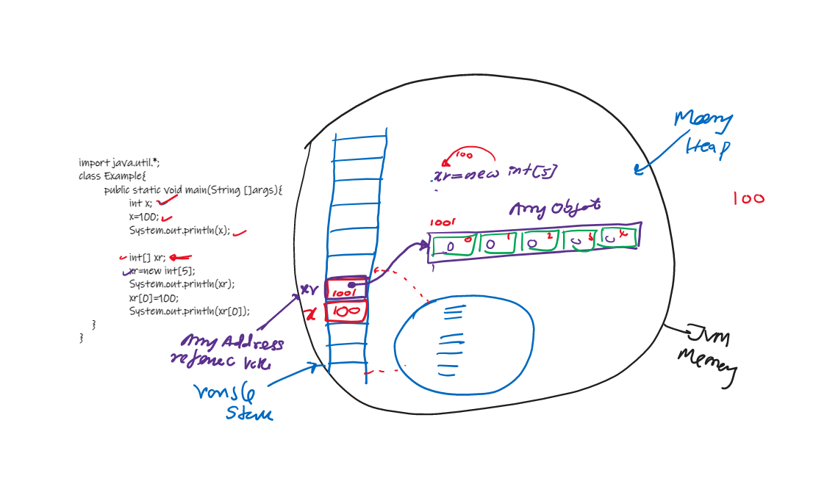

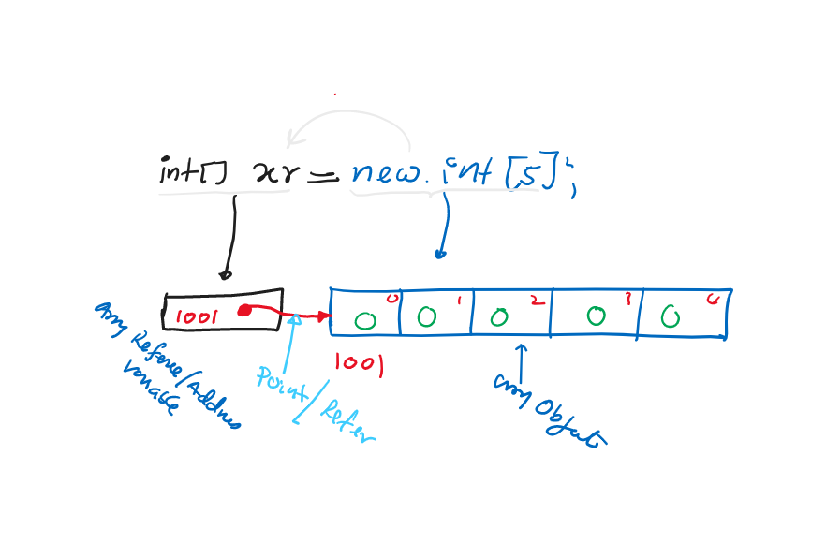

//////////////////////////////////////////////////////////////////////////////////////////////////////////////////////////

Q377 Case II

==========

import java.util.*;

class Example{

public static void main(String []args){

int[] xr; //Create an array address/reference [array declaration]

xr=new int[5]; //Create an array Object[array constructions]

xr[0]=100; //[array initialization]

    }

}

//////////////////////////////////////////////////////////////////////////////////////////////////////////////////////////

Q378 Case III

===========

import java.util.*;

class Example{

public static void main(String []args){

int[] a; //Legal

int []b; //Legal

int c[]; //Legal

int d[5]; //Illegal

    }

}

//////////////////////////////////////////////////////////////////////////////////////////////////////////////////////////

Q379 Case IV

===========

import java.util.*;

class Example{

public static void main(String []args){

int[] a=new int[5];

//int[] b=new int[]; //Illegal

int[] c={10,20,30,40,50};

int[] d;

//d={10,20,30,40,50}; //Illegal

int[] e=new int[]{10,20,30,40,50};

int[] f;

f=new int[]{10,20,30,40,50}; //Legal

int[] g=new int[5]{10,20,30,40,50}; //Illegal

    }

}

//////////////////////////////////////////////////////////////////////////////////////////////////////////////////////////

Q380 Case V Default Values

======================

import java.util.*;

class Example{

public static void main(String []args){

int x;

//System.out.println(x); //Illegal

int[] xr=new int[3];

System.out.println(xr[0]+" "+xr[1]+" "+xr[2]); //Prints default values of "int" -->0 0 0

    }

}

//////////////////////////////////////////////////////////////////////////////////////////////////////////////////////////

Q381

import java.util.*;

class Example{

public static void main(String []args){

int[] a=new int[3];

long[] b=new long[3];

float[] c=new float[3];

double[] d=new double[3];

System.out.println(a[0]+" "+a[1]+" "+a[2]); //0 0 0

System.out.println(b[0]+" "+b[1]+" "+b[2]); //0 0 0

System.out.println(c[0]+" "+c[1]+" "+c[2]); //0.0 0.0 0.0

System.out.println(d[0]+" "+d[1]+" "+d[2]); //0.0 0.0 0.0

    }

}

//////////////////////////////////////////////////////////////////////////////////////////////////////////////////////////

Q382 Default value of char

======================

import java.util.*;

class Example{

public static void main(String []args){

char[] stGrade=new char[5];

System.out.println(stGrade[0]+" "+stGrade[1]); //print nothing

int code=stGrade[0];

System.out.println("Default value of char : "+code); //0

    }

}

//////////////////////////////////////////////////////////////////////////////////////////////////////////////////////////

Q383 Default value of “boolean”

==========================

import java.util.*;

class Example{

public static void main(String []args){

boolean[] b=new boolean[3];

System.out.println(b[0]+" "+b[1]+" "+b[2]); //false false false

    }

}

//////////////////////////////////////////////////////////////////////////////////////////////////////////////////////////

Q384

import java.util.*;

class Example{

public static void main(String []args){

String[] names=new String[3];

System.out.println(names[0]+" "+names[1]+" "+names[2]);

    }

}

//////////////////////////////////////////////////////////////////////////////////////////////////////////////////////////

Q385 Case VI length/size of an array

=============================

import java.util.*;

class Example{

public static void main(String []args){

int[] marks=new int[12];

System.out.println("length/size : "+marks.length); //12

    }

}

//////////////////////////////////////////////////////////////////////////////////////////////////////////////////////////

Q386 Exercise

===========

import java.util.*;

class Example{

public static void main(String []args){

int[] nos={1,2,1,3,4,3,4,5,4,5,6,7,6,2,5,9,5,4,2,8,3,9,4};

System.out.println("Size/length : "+nos.length); //

//find total

int total=0;

for(int i=0; i<nos.length ; i++){

total+=nos[i];

}

System.out.println("total : "+total);

    }

}

//////////////////////////////////////////////////////////////////////////////////////////////////////////////////////////

Q387 Case VIII Array Index error

==========================

import java.util.*;

class Example{

public static void main(String []args){

int[] ar=new int[3];

System.out.println(ar[0]);

System.out.println(ar[1]);

System.out.println(ar[2]);

System.out.println(ar[3]); //Legal, runtime error

    }

}

//////////////////////////////////////////////////////////////////////////////////////////////////////////////////////////

Q388

import java.util.*;

class Example{

public static void main(String []args){

int[] ar=new int[3];

ar[0]=100;

ar[99]=200; //Legal

ar[-5]=400; //Legal

    }

}

//////////////////////////////////////////////////////////////////////////////////////////////////////////////////////////

Q389 Case IX

===========

import java.util.*;

class Example{

public static void main(String []args){

int[] xr=new int[3];

int x=100;

double[] dr=new double[3];

double d=12.3;

xr[0]=x;

x=xr[0];

x=xr;

xr=x;

x=(int)xr;

d=x;

x=d;

x=(int)d;

x=dr[0];

dr[0]=x;

x=(int)dr[0];

dr=xr;

xr=dr;

xr=(int[])dr;

dr=(double[])xr;

    }

}

//////////////////////////////////////////////////////////////////////////////////////////////////////////////////////////

Q390 Case X (Class “Arrays”)

=========== ===========

import java.util.*;

class Example{

public static void main(String []args){

int[] xr={34,23,65,87,91,12,16,78,29,81,49};

String s1=Arrays.toString(xr);

System.out.println(s1);//[34,23,65,87,91,12,16,78,29,81,49]

Arrays.sort(xr);

System.out.println(Arrays.toString(xr));//[]

    }

}

//////////////////////////////////////////////////////////////////////////////////////////////////////////////////////////

Q391 Exercise

===========

import java.util.*;

class Example{

public static void main(String []args){

int[] xr={100,200,300,400};

System.out.println(Arrays.toString(xr));//[100, 200, 300, 400]

xr=new int[10];

System.out.println(Arrays.toString(xr));//[]

    }

}

//////////////////////////////////////////////////////////////////////////////////////////////////////////////////////////

**Passing an array to a method**

//////////////////////////////////////////////////////////////////////////////////////////////////////////////////////////

Q392 Step I

=========

import java.util.*;

class Example{

public static void main(String []args){

int[] xr={90,78,87,12,54,14,71,19,56,76};

printArray(); //[90,78,87,12,54,14,71,19,56,76]

    }

}

//////////////////////////////////////////////////////////////////////////////////////////////////////////////////////////

Q393 Step II

==========

import java.util.*;

class Example{

public static void printArray(){

System.out.print("[");

for (int i = 0; i < xr.length; i++){

System.out.print(xr[i]+", ");

}

System.out.println("\b\b]");

}

public static void main(String []args){

int[] xr={90,78,87,12,54,14,71,19,56,76};

printArray(); //[90,78,87,12,54,14,71,19,56,76]

    }

}

//////////////////////////////////////////////////////////////////////////////////////////////////////////////////////////

Q394 Step III

==========

import java.util.*;

class Example{

public static void printArray(){

System.out.print("[");

for (int i = 0; i < xr.length; i++){

System.out.print(xr[i]+", ");

}

System.out.println("\b\b]");

}

public static void main(String []args){

int[] xr={90,78,87,12,54,14,71,19,56,76};

printArray(xr); //[90,78,87,12,54,14,71,19,56,76]

    }

}

//////////////////////////////////////////////////////////////////////////////////////////////////////////////////////////

Q395 Step iv

==========

import java.util.*;

class Example{

public static void printArray(int[] xr){

System.out.print("[");

for (int i = 0; i < xr.length; i++){

System.out.print(xr[i]+", ");

}

System.out.println("\b\b]");

}

public static void main(String []args){

int[] xr={90,78,87,12,54,14,71,19,56,76};

printArray(xr); //[90,78,87,12,54,14,71,19,56,76]

    }

}

//////////////////////////////////////////////////////////////////////////////////////////////////////////////////////////

**Q396 Method Call by values**

**=======================**

import java.util.*;

class Example{

public static void increment(int a, int b, int c, int d){

a++;

b++;

c++;

d++;

}

public static void main(String []args){

int[] xr={100,200,300,400};

System.out.println(Arrays.toString(xr));

increment(xr[0],xr[1],xr[2],xr[3]);

System.out.println(Arrays.toString(xr));

}

}

//////////////////////////////////////////////////////////////////////////////////////////////////////////////////////////

**Q397 Method call by reference**

**=========================**

import java.util.*;

class Example{

public static void increment(int[] a){

a[0]++;

a[1]++;

a[2]++;

a[3]++;

}

public static void main(String []args){

int[] xr={100,200,300,400};

System.out.println(Arrays.toString(xr));

increment(xr);

System.out.println(Arrays.toString(xr));

}

}

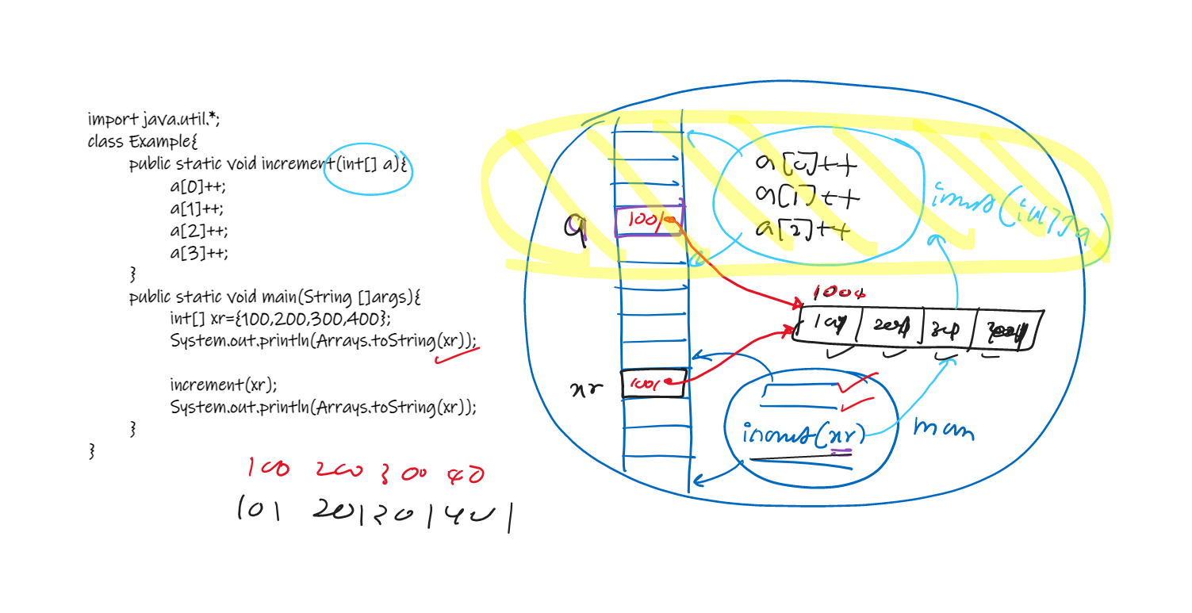

//////////////////////////////////////////////////////////////////////////////////////////////////////////////////////////

Q398 Exercise

===========

import java.util.*;

class Example{

public static void main(String []args) {

Scanner input=new Scanner(System.in);

System.out.print("Input no of students : ");

final int N=input.nextInt();

//1. Create an array to store student's marks, named "marks", size

int[] marks=createAnArray(N);

//2. Read and store marks [Read random number 0 to 100]

readMarks(marks);

//3. Find Total

int total=findTotal(marks);

//4. Find max

int max=findMax(marks);

//5. Find min

int min=findMin(marks);

//6. Print marks [45, 23,.....]

printMarks(marks);

System.out.println("Total   : "+total);

System.out.println("Maximum : "+max);

System.out.println("Minimum : "+min);

    }

}

//////////////////////////////////////////////////////////////////////////////////////////////////////////////////////////

Q399 From Q398

==============

import java.util.*;

class Example{

public static int[] createAnArray(int size){

int[] tempArray=new int[size];

return tempArray;

}

public static void readMarks(int[] a){

Random r=new Random();

for (int i = 0; i < a.length; i++){

a[i]=r.nextInt(101);

}

}

public static void main(String []args) {

Scanner input=new Scanner(System.in);

System.out.print("Input no of students : ");

final int N=input.nextInt();

//1. Create an array to store student's marks, named "marks", size

int[] marks=createAnArray(N);

//2. Read and store marks [Read random number 0 to 100]

readMarks(marks);

//3. Find Total

int total=findTotal(marks);

//4. Find max

int max=findMax(marks);

//5. Find min

int min=findMin(marks);

//6. Print marks [45, 23,.....]

printMarks(marks);

System.out.println("Total   : "+total);

System.out.println("Maximum : "+max);

System.out.println("Minimum : "+min);

    }

}

//////////////////////////////////////////////////////////////////////////////////////////////////////////////////////////

Q400 From Q399

==============

import java.util.*;

class Example{

public static int[] createAnArray(int size){

int[] tempArray=new int[size];

return tempArray;

}

public static void readMarks(int[] a){

Random r=new Random();

for (int i = 0; i < a.length; i++){

a[i]=r.nextInt(101);

}

}

public static int findTotal(int[] a){

int total=0;

for (int i = 0; i < a.length; i++){

total+=a[i];

}

return total;

}

public static int findMax(int[] a){

int max=a[0];

for (int i = 1; i < a.length; i++){

if(a[i]>max){

max=a[i];

}

}

return max;

}

public static int findMin(int[] a){

int min=a[0];

for (int i = 1; i < a.length; i++){

if(a[i]<min){

min=a[i];

}

}

return min;

}

public static void printMarks(int[] a){

System.out.print("[");

for (int i = 0; i < a.length; i++){

System.out.print(a[i]+", ");

}

System.out.println("\b\b]");

}

public static void main(String []args) {

Scanner input=new Scanner(System.in);

System.out.print("Input no of students : ");

final int N=input.nextInt();

//1. Create an array to store student's marks, named "marks", size

int[] marks=createAnArray(N);

//2. Read and store marks [Read random number 0 to 100]

readMarks(marks);

//3. Find Total

int total=findTotal(marks);

//4. Find max

int max=findMax(marks);

//5. Find min

int min=findMin(marks);

//6. Print marks [45, 23,.....]

printMarks(marks);

System.out.println("Total   : "+total);

System.out.println("Maximum : "+max);

System.out.println("Minimum : "+min);

    }

}

//////////////////////////////////////////////////////////////////////////////////////////////////////////////////////////

**Java for-each Loop**

//////////////////////////////////////////////////////////////////////////////////////////////////////////////////////////

Q401

import java.util.*;

class Example{

public static void main(String []args) {

int[] ar={23,76,13,98,25,57,72,82,25,27,84,11};

for(int i=0; i<ar.length; i++){

System.out.print(ar[i]+"  ");

}

System.out.println();

//--------------------------------------------

for(int a : ar){

System.out.print(a+"  ");

}

}

}

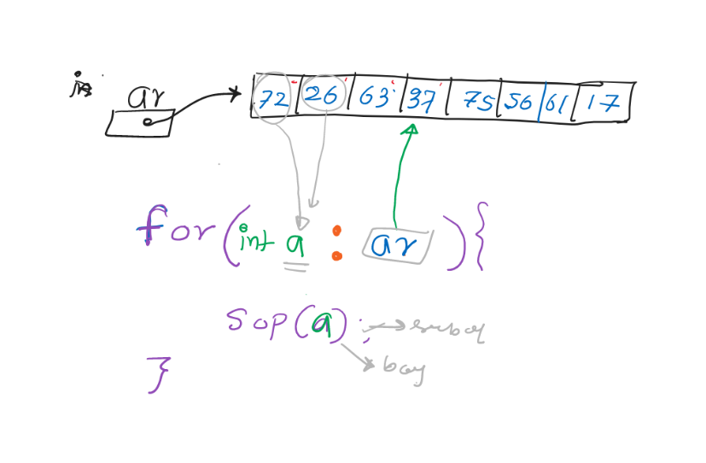

//////////////////////////////////////////////////////////////////////////////////////////////////////////////////////////

Q402 Exercise

============

import java.util.*;

class Example{

public static void main(String []args) {

int[] ar={23,76,13,98,25,57,72,82,25,27,84,11};

int count=0;

for(int a : ar){

count++;

}

System.out.println(count==ar.length);

System.out.println("count : "+count);

System.out.println("length: "+ar.length);

}

}

//////////////////////////////////////////////////////////////////////////////////////////////////////////////////////////

Q403 Exercise

============

import java.util.*;

class Example{

public static void main(String []args) {

int[] ar={10,20,30,40,50};

System.out.println(Arrays.toString(ar));

//increment values using "for-each"

for(int a : ar){

a++;

}

System.out.println(Arrays.toString(ar));

System.out.println();

//increment using for-loop

for(int i=0; i<ar.length; i++){

ar[i]++;

}

System.out.println(Arrays.toString(ar));

}

}

//////////////////////////////////////////////////////////////////////////////////////////////////////////////////////////

Q404 Exercise

===========

import java.util.*;

class Example{

public static void main(String []args) {

int[] ar={10,20,30,40,50};

for(int a : ar){

a++;

}

System.out.println(a); //Illegal "a"

}

}

//////////////////////////////////////////////////////////////////////////////////////////////////////////////////////////

Q405 Exercise

===========

import java.util.*;

class Example{

public static void main(String []args) {

int[] ar={10,20,30,40,50};

int a;

for(a : ar){ //Illegal

a++;

}

}

}

//////////////////////////////////////////////////////////////////////////////////////////////////////////////////////////

Q406 Exercise

============

import java.util.*;

class Example{

public static void main(String []args) {

int[] ar={10,20,30,40,50};

for(/*Insert code here */ : ar){ //Illegal

a++;

}

}

}

//A. byte a //Illegal

//B. short a //Illegal

//C. char a //Illegal

//D. int a //Legal

//E. long a //Legal

//G. float a //Legal

//H. double a //Legal